

Ansible

Hands on Training



Agenda

●

Fundamentals

●

Key Components

●

Best practices

●

Spring Boot REST API Deployment

●

CI with Ansible

●

Ansible for AWS

●

Provisioning a Docker Host

●

Docker&Ansible



Fundamentals



Fundamentals

●

What is Ansible?

●

Why Ansible?

●

Terms

○

Inventory

○

Host

○

Group

○

Playbook

○

Play

○

Task

○

Modules

○

Library



What is Ansible?

●

Radically simple IT automation engine that automates

○

Cloud provisioning

○

Configuration management

○

Application deployment

○

Intra-service orchestration

Why Ansible?

* Simple
  1. Easy to write, read, maintain and evolve- without writing scripts or custom code
* Fast to learn and setup
  1. It uses a very simple language (YAML, in the form of Ansible Playbooks) that allow you to describe your automation jobs in a way that approaches plain English.



Why Ansible?

●

Efficient

○

Doesn't require a custom agent or software to install

○

Ansible works by connecting to your nodes and pushing

out small programs, called "Ansible modules" to them.

●

Secure

○

No agent

○

Runs on OpenSSH



Inventory

Ansible works against multiple systems in your infrastructure at

the same time. It does this by selecting portions of systems listed

in Ansible’s inventory file, which defaults to being saved in the

location /etc/ansible/hosts.

[

webservers

]

192.168.35.140

192.168.35.141

192.168.35.142

192.168.35.143

[

appservers

]

192.168.100.1

192.168.100.2

192.168.100.3

[

dbservers

]

172.35.0.5



Host

A host is simply a remote machine that Ansible manages. They

can have individual variables assigned to them, and can also be

organized in groups.

[

webservers

]

192.168.35.140

192.168.35.141

192.168.35.142

192.168.35.143

[

appservers

]

192.168.100.1

192.168.100.2

192.168.100.3

[

dbservers

]

172.35.0.5



Group

A group consists of several hosts assigned to a pool that can be

conveniently targeted together, and also given variables that they

share in common.

[

webservers

]

192.168.35.140

192.168.35.141

192.168.35.142

192.168.35.143

[

appservers

]

192.168.100.1

192.168.100.2

192.168.100.3

[

dbservers

]

172.35.0.5



Playbook

Playbooks are the language by which Ansible orchestrates,

configures, administers, or deploys systems. Playbooks contain

Plays

.

Install application server and database server

Install & Start Apache Tomcat

Install & Start MySQL & Import Data

Install Java

Install Tomcat

Install MySQL

Import Data



Play

A play is a mapping between a set of hosts selected by a host

specifier and the

tasks

which run on those hosts to define the

role that those systems will perform.

Install application server and database server

Install & Start Apache Tomcat

Install & Start MySQL & Import Data

Install Java

Install Tomcat

Install MySQL

Import Data



Task

Tasks combine an action with a name and optionally some other

keywords (like looping directives). Tasks call

modules

.

Install application server and database server

Install & Start Apache Tomcat

Install & Start MySQL & Import Data

Install Java

Install Tomcat

Install MySQL

Import Data



Module

Modules are the units of work that Ansible ships out to remote

machines. Ansible refers to the collection of available modules as

a

library

.

Install Java

Download Oracle JDK

get_url:

url:http://download.oracle.com

dest:jdk-1.8.0-linux-x64.rpm

Install Oracle JDK

yum:

name:

jdk-1.8.0-linux-x64.rpm

state: present



Library

A collection of modules made available to /usr/bin/ansible or an

Ansible playbook.



Install Ansible

*# install the epel-release RPM if needed on CentOS, RHEL, or Scientific Linux*

$ sudo yum install ansible

Latest Release via Yum

$ sudo apt-get install software-properties-common

$ sudo apt-add-repository ppa:ansible/ansible

$ sudo apt-get update

$ sudo apt-get install ansible

Latest Release via Apt



Install Ansible

$ sudo easy_install pip

$ sudo pip install ansible

Latest Release via Pip



Control Machine System Requirements

Currently Ansible can be run from any machine with

Python 2.6

or 2.7

installed (Windows isn’t supported for the control

machine).

# Node Machine System Requirements

On the managed nodes, you need a way to communicate, which is normally ssh. By default this uses sftp. If that’s not available, you can switch to scp in ansible.cfg.

You also need Python 2.4 or later. If you are running less than Python 2.5 on the remotes, you will also need:

● python-simplejson



LAB #1

Install Ansible



Install Ansible

$ git clone

https://github.com/maaydin/ansible-tutorial.git

$ cd ansible-tutorial

Let’s start with cloning the repository we will walk during the trainig

$ vagrant up

$ vagrant ssh control

$ sudo apt-get install software-properties-common

$ sudo apt-add-repository ppa:ansible/ansible

$ sudo apt-get update

$ sudo apt-get install ansible

Provision the Control Machine and install ansible



Validate Ansible Installation

$ ansible --version

ansible 2.2.0.0

config file = /etc/ansible/ansible.cfg

configured module search path = Default w/o overrides

Check the ansible version



Ad-Hoc Commands on Local Machine

$ ansible -m ping localhost

[WARNING]: provided hosts list is empty, only localhost is available

localhost | SUCCESS => {

"changed": false,

"ping": "pong"

}

Ping the localhost



Key Components



Inventory



Inventory Concepts

●

Hosts & Groups

●

Host & Group Variables

●

Groups of Groups

●

Inventory Parameters

●

Dynamic Inventory



Hosts & Groups

The format for

/etc/ansible/hosts

is an INI-like format and looks

like this:

mail.example.com

[

]

webservers

foo.example.com

bar.example.com

[

]

dbservers

one.example.com

two.example.com

three.example.com



Hosts & Groups

Different SSH port:

web1:2222

Using aliases:

web2 ansible_port=22 ansible_host=192.168.35.102

Ranges:

[

]

webservers

www[01:50].example.com



Host & Group Variables

Assign variables to hosts that will be used later in playbooks

[

]

webservers

web1 http_port=80 https_port=443

web2 http_port=8080 https_port=8443

Variables can also be applied to an entire group at once

[

]

webservers:vars

ntp_server=tr.pool.ntp.org

proxy=proxy.example.com



Groups of Groups

To make groups of groups use the

:

children

suffix.

[

]

euwest

host1

[

]

eucentral

host2

[

]

eu:children

euwest

eucentral



Inventory Parameters

ansible_user

The default ssh user name to use.

ansible_ssh_private_key_file

Private key file used by ssh. Useful if using multiple keys and you don’t want to use

SSH agent.

ansible_become

Equivalent to ansible_sudo or ansible_su, allows to force privilege escalation



Dynamic Inventory

Inventory can also be gathered on demand from other sources dynamically. Those

sources include:

●

Cobbler (

http://cobbler.github.io/

)

●

Cloud APIs

○

Rackspace

○

Amazon

○

Digital Ocean

○

OpenStack



LAB #2

Create the Inventory



Create the Hosts in the Inventory

web1 192.168.35.101

web2 192.168.35.102

app 192.168.35.103

db 192.168.35.104

Create the Ansible Inventory for given hosts:



Create the Groups in the Inventory

webservers: web1 & web2

appservers: app

dbservers: db

dc: webservers & appservers & dbservers

Create the Inventory for given groups consist of below servers & groups



Inventory

web1 ansible_host=192.168.35.101

web2 ansible_host=192.168.35.102

app ansible_host=192.168.35.103

db ansible_host=192.168.35.104

[

]

webservers

web1

web2

[

]

appservers

app

[

]

dbservers

db

[

]

dc:children

webservers

appservers

dbservers



Ad-Hoc Commands on Inventory

$ ansible -m ping web1

$ ansible -m ping app

$ ansible -m ping webservers

$ ansible -m ping dc

Ping the hosts and groups you defined



Tip #1: SSH Keys

$ vagrant ssh control

$ ssh-agent bash

$ ssh-add /vagrant/keys/key

To set up SSH agent to avoid retyping passwords, you can add the private key

$ ssh-keygen

Creating a New SSH Key Pair



Tip #2: Host Key Checking

[

]

defaults

host_key_checking = False

If you wish to disable host key checking, you can do so by editing

/etc/ansible/ansible.cfg

or

~/.ansible.cfg

:

$ export ANSIBLE_HOST_KEY_CHECKING=False

Alternatively this can be set by an environment variable:



Ad-Hoc Commands on Inventory

$ ansible -m shell -a 'ls -al' web1

$ ansible -m shell -a 'whoami' app

$ ansible -m shell -a 'ifconfig' webservers

$ ansible -m shell -a 'hostname' dc

Run some shell commands on the hosts and groups you defined



Tip #3: Patterns

$ ansible -m ping all

$ ansible -m ping web*

$ ansible -m ping 'appservers:dbservers'

$ ansible -m ping 'dc:!webservers'

$ ansible -m ping 'dc:&webservers'

A pattern usually refers to a set of groups (which are sets of hosts)



Tasks



Tasks

A task is a discrete action that is a declaration about the state of a

system.

●

Example Tasks:

●

Directory should exist

●

Package should be installed

●

Service should be running

●

Cloud Instance should exist



Tasks as Ad-Hoc Commands

Ansible can execute single tasks on sets of hosts to full-fill an

ad-hoc declarations.

$ ansible webservers -m file -a "path=/var/www/html/assets state=directory"

$ ansible webservers -m apt -a "name=nginx state=present"

$ ansible webservers -m service -a "name=nginx enabled=yes state=started"



Modules

# Modules

Modules are the bits of code copied to the target system to be executed to satisfy the task declaration.

* Code need not exist on remote host -- ansible copies it over
* Many modules come with Ansible -- "batteries included"
* Custom modules can be developed easily
* Command/shell modules exists for simple commands
* Script module exists for using existing code
* Raw module exists for executing raw commands over ssh



Modules Documentation

●

Module listing and documentation via ansible-doc

$ ansible-doc -l

$ ansible-doc apt

●

Module index

http://docs.ansible.com/ansible/modules_by_category.html



LAB #3

Using Common Modules



Install Nginx with Ad-Hoc Commands

$ ansible -m apt -a "name=nginx state=present update_cache=yes" web1

Install the nginx server on webservers with apt module

# Tip #4: Become (Privilege Escalation)

Ansible can use existing privilege escalation systems to allow a user to execute tasks as another.

Ansible allows you to ‘become’ another user, different from the user that logged into the machine (remote user). This is done using existing privilege escalation tools, which you probably already use or have configured, like sudo, su, pfexec, doas, pbrun, dzdo, ksu and others.

$ ansible -m shell -a "whoami" web1 --become



Install Nginx with Ad-Hoc Commands

$ ansible -m apt -a "name=nginx state=present update_cache=yes" web1 --become

Install the nginx server on webservers with apt module

$ ansible -m service -a "name=nginx state=started enabled=yes" webservers

--

become

Ensure service enabled and started on webservers with service module



Install Nginx with Ad-Hoc Commands

$ ansible -m file -a "path=/usr/share/nginx/html state=directory" webservers

--

become

Ensure /usr/share/nginx/html directory exists on webservers with file module

$ ansible -m copy -a "src=index.html dest=/usr/share/nginx/html/index.html"

webservers --become

Update /usr/share/nginx/html/index.html file a custom file with copy module



Modules Exercises

●

Ensure

default-jdk

package installed on appservers.

●

Ensure

greeting

user created on appservers.

●

Ensure

/var/log/greeting

directory owned by

greeting

user created on appservers.

●

Ensure

mongodb-server

package installed on dbservers.



Plays



Plays

Plays are ordered sets of tasks to execute against host selections

from your inventory.

Install application server and database server

Install & Start Apache Tomcat

Install & Start MySQL & Import Data

Install Java

Install Tomcat

Install MySQL

Import Data



Plays

---

-

name: Nginx Play

hosts: webservers

vars:

assets_dir: /var/www/html/static

become: true

tasks:

- name: ensure nginx is installed

apt: name=nginx state=present

- name: ensure directory exists

file: path={{ assets_dir }} state=directory

Host

Selection

Privilege

Escalation

Naming

Variables

Tasks



Conditionals

tasks:

- command: /bin/false

register: result

ignore_errors: True

- command: /bin/something

when: result|failed

- command: /bin/something_else

when: result|succeeded

- command: /bin/still/something_else

when: result|skipped



Loops

-

name: add several users

user: name={{ item.name }} state=present groups={{ item.groups }}

with_items:

- { name: 'testuser1', groups: 'wheel' }

- { name: 'testuser2', groups: 'root' }

-

name: add several users with sequence

user: name=testuser{{ item }} state=present groups=wheel

with_sequence: start=3 end=16



Handlers

tasks:

- name: Update nginx default config

copy: src=default.conf dest=/etc/nginx/sites-enabled/default

notify:

- Test nginx configuration

- Reload nginx configuration

handlers:

- name: Test nginx configuration

command: nginx -t

- name: Reload nginx configuration

command: nginx -s reload



Playbooks



Playbooks

Playbooks are ordered sets of plays to execute against inventory

selections.

Install application server and database server

Install & Start Apache Tomcat

Install & Start MySQL & Import Data

Install Java

Install Tomcat

Install MySQL

Import Data



Running Playbooks

$ ansible-playbook play.yml

To run a play book use

ansible-playbook

command.

$ ansible-playbook -i production play.yml

Hosts can be changed by providing a inventory file

$ ansible-playbook -e "assets_dir=/var/www/html/assets/" play.yml

Environment variables can be set globally



Running Playbooks

$ ansible-playbook -i production play.yml

Hosts can be limited by providing a subset

$ ansible-playbook -f 30 play.yml

Number of parallel processes to use can be specified (default=5)



LAB #4

Running Playbooks



Install Nginx with a Single Play

Install the nginx server on webservers

---

-

hosts: webservers

become: true

tasks:

- name: Install nginx

apt: name=nginx state=present

- name: Start nginx

service: name=nginx state=started enabled=yes



Install Nginx with a Single Play

$ ansible-playbook /vagrant/lab-04/install-nginx.yml -l web1

PLAY [webservers] **************************************************************

TASK [setup] *******************************************************************

ok: [web1]

TASK [Install nginx] ***********************************************************

ok: [web1]

TASK [Start nginx] *************************************************************

ok: [web1]

PLAY RECAP *********************************************************************

web1

:

ok=3

changed=0 unreachable=0 failed=0



Install Nginx & JDK & MongoDB in a Playbook

●

Install the nginx server on webservers

●

Install JDK on appservers

●

Install MongoDB on dbservers



Roles

# Roles

Roles are portable units of task organization in playbooks and is the best way to organize your playbooks.

Roles are just automation around ‘include’ directives, and really

don’t contain much additional magic beyond some improvements to search path handling for referenced files.

However, that can be a big thing!



Example Project Structure

**site.yml**

**webservers.yml**

**fooservers.yml**

**roles/**

**common/**

**files/**

**templates/**

**tasks/**

**handlers/**

**vars/**

**defaults/**

**meta/**

**webservers/**

**tasks/**



Example Playbook

**---**

**-**

**hosts: webservers**

**roles:**

**- common**

**- webservers**



Example Role

**---**

**-**

**name: Install EPEL repo**

**yum: name=epel-release state=present**

**-**

**name: Install nginx server**

**yum: name=nginx enablerepo=epel state=present**

**-**

**name: Create static content directory**

**file: path=/usr/share/nginx/static state=directory**



LAB #5

Running Playbooks with Roles



Install NTP & Nginx with in Roles

Install the ntp service & nginx server on webservers and deploy static content

---

-

hosts: webservers

become: true

roles:

- ntp

- nginx

- deploy_static_content



Install Nginx & JDK & MongoDB with in Roles

●

Install ntp service on all servers

●

Install the nginx server on webservers

●

Deploy static content on webservers

●

Install JDK on appservers

●

Install MongoDB on dbservers



Best Practices



●

Strive for simplification

●

Optimize for readability

●

Think declaratively

Complexity Kills



Project Layout

├──

config.yml

├──

provision.yml

├──

roles

│

├──

myapp

│

│

│

│

│

│

│

├──

nginx

│

│

└──

etc.etc

│

└──

proxy

├──

tasks

│

└──

main.yml

└──

etc.etc

│

└──

etc.etc

└──

site.yml



Meaningful Inventory Names

10.1.2.75

10.1.5.45

10.1.4.5

10.1.0.40

w14301.acme.com

w17802.acme.com

W19203.acme.com

w19304.acme.com

db1 ansible_host=10.1.2.75

db2 ansible_host=10.1.5.45

db3 ansible_host=10.1.4.5

db4 ansible_host=10.1.0.40

web1 ansible_host=w14301.acme.com

web2 ansible_host=w17802.acme.com

web3 ansible_host=w19203.acme.com

web4 ansible_host=w19203.acme.com



Vertical Reading is Easier

-

name: install telegraf

yum: name=telegraf-{{ telegraf_version

}}

state=present update_cache=yes

disable_gpg_check=yes enablerepo=telegraf

-

name: install telegraf

yum: YES

name: telegraf-{{ telegraf_version }}

state: present

update_cache: yes

disable_gpg_check: yes

enablerepo: telegraf



Meaningful Task Names

-

hosts: web

tasks:

- yum:

name: httpd

state: latest

- service:

name: httpd

state: started

enabled: yes

-

hosts: web

name: installs and starts apache

tasks:

- name: install apache packages

yum:

name: httpd

state: latest

- name: starts apache service

service:

name: httpd

state: started

enabled: yes

# Meaningful Task Names

|  |  |  |
| --- | --- | --- |
| PLAY [web]  *****************************************  TASK [setup] *****************************************  ok: [web1]    TASK [yum] *****************************************  ok: [web1]    TASK [service] ***************************************** ok: [web1] |  | PLAY [installs and starts apache]  ******************************************  TASK [setup]  ****************************************** ok: [web1]  TASK [install apache packages]  ****************************************** ok: [web1]  TASK [starts apache service]  ******************************************  ok: [web1] |



Use Smoke Tests

-

name: check for proper response

uri:

url: http://localhost/myapp

return_content: yes

register: result

until: '"Hello World" in result.content'

retries: 10

delay: 1



Consider Writing a Module

-

hosts: all

vars:

cert_store: /etc/mycerts

cert_name: my cert

tasks:

- name: check cert

shell: certify --list --name={{ cert_name }}

register: output

- name: create cert

command: certify --create --user=chris

when: output.stdout.find(cert_name)" != -1

register: output

- name: sign cert

command: certify --sign

-

hosts: all

vars:

cert_store: /etc/mycerts

cert_name: my cert

tasks:

- name: create and sign cert

certify:

state: present

sign: yes

user: chris

name: "{{ cert_name }}"

cert_store: "{{ cert_store }}"



LAB #6

Spring Boot Rest API Deployment



Deploy Greeting REST Service

Download and build the sample REST service from github and deploy on appservers.

$ git clone

https://github.com/spring-guides/gs-rest-service.git

$ cd gs-rest-service/complete

$ mvn package

* Requires java 8



Tip #5: Installing JDK 8 on Ubuntu 14.04

You should add ‘

ppa:openjdk-r/ppa’ repo first:

---

-

name: Install openjdk repository

apt_repository: repo='ppa:openjdk-r/ppa'

-

name: Install openjdk

apt: name=openjdk-8-jdk state=present



Continuous Integration

with Ansible



●

https://wiki.jenkins-ci.org/display/JENKINS/Ansible+Plugin

Jenkins Ansible Plugin

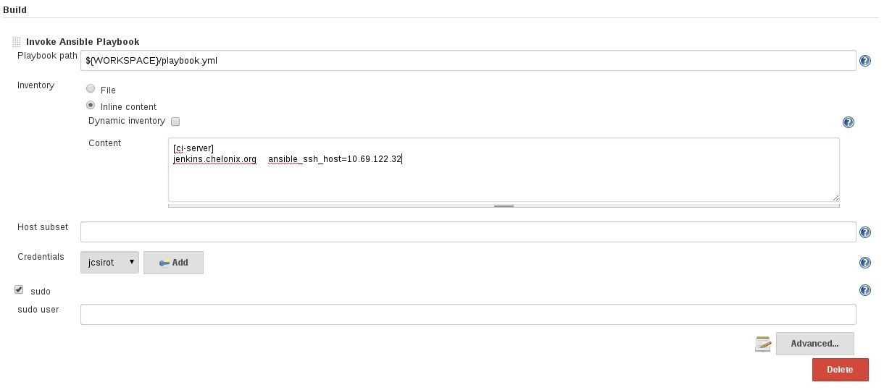

Jenkins Ansible Plugin

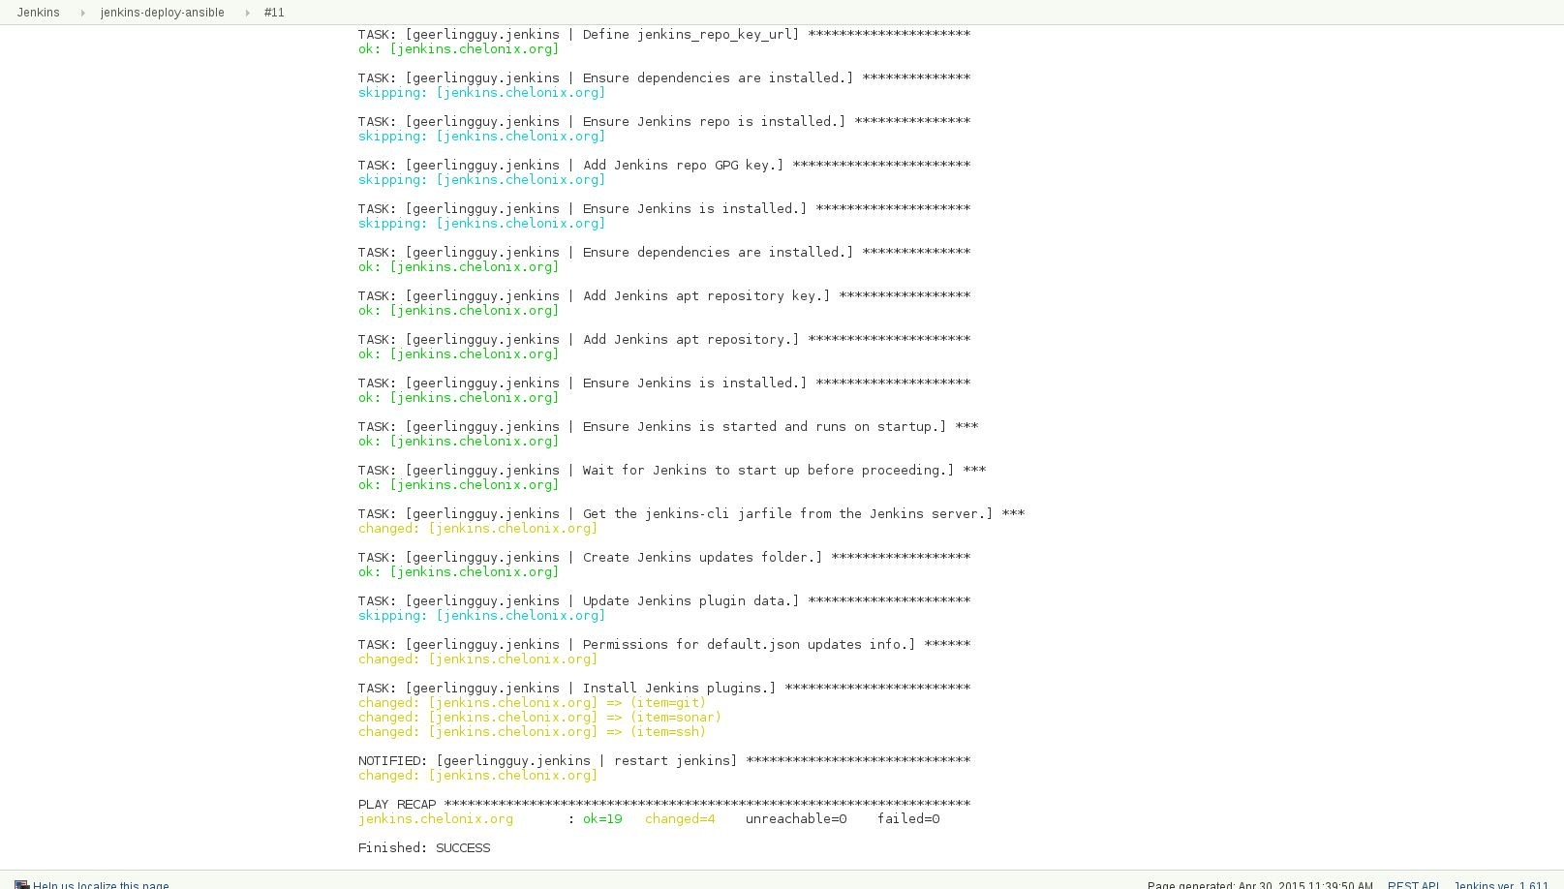

Jenkins Ansible Plugin

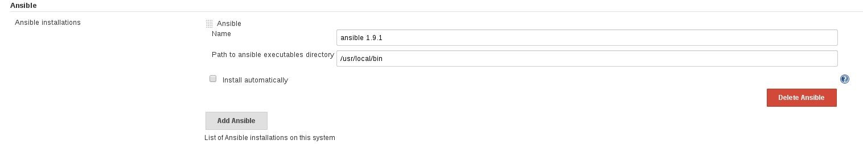

Teamcity Ansible Plugin

●

https://github.com/andreizhuk/tc-ansible-runner

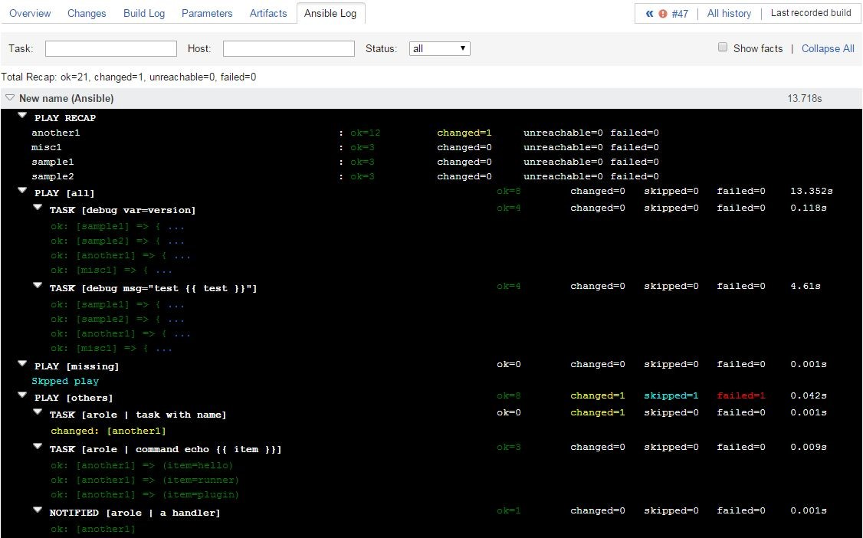

Ansible for AWS



Boto is a Python package that provides interfaces to Amazon

Web Services. Currently, all features work with Python 2.6 and

2.7

. Ansible uses boto to communicate with AWS API.

It can be installed via OS package manager or pip.

Boto

$ apt-get install python-boto

$ pip install boto

# Amazon EC2 Inventory Management

To get started with dynamic inventory management, you’ll need to grab the EC2.py script and the EC2.ini config file. The EC2.py script is written using the Boto EC2 library and will query AWS for your running Amazon EC2 instances.

$ wget https://raw.githubusercontent.com/ansible/ansible/devel/contrib/inventory/ec2.py

$ wget https://raw.githubusercontent.com/ansible/ansible/devel/contrib/inventory/ec2.ini



Amazon EC2 Inventory Management

$ export AWS_ACCESS_KEY_ID='YOUR_AWS_API_KEY'

$ export AWS_SECRET_ACCESS_KEY='YOUR_AWS_API_SECRET_KEY'

$ export ANSIBLE_HOSTS=/etc/ansible/ec2.py

$ export EC2_INI_PATH=/etc/ansible/ec2.ini

$ ssh-agent bash

$ ssh-add ~/.ssh/keypair.pem



Amazon EC2 Inventory Management

$ /etc/ansible/ec2.py --list

$ ansible -m ping tag_Ansible_Slave

10.1.2.137

{

| success >>

"changed": false,

"ping": "pong"

}

10.1.2.136

{

| success >>

"changed": false,

"ping": "pong"

}

# Ansible Cloud Modules

From the beginning, Ansible has offered deep support for AWS. Ansible can be used to define, deploy, and manage a wide variety of AWS services. Even the most complicated of AWS environments can be easily described in Ansible playbooks.

● http://docs.ansible.com/ansible/list_of_cloud_modules.html



Create Elastic Load Balancer

-

name: Configure Load Balancer

ec2_elb_lb:

name: y-lb-{{suffix}}

state: present

region: "{{ec2_region}}"

connection_draining_timeout: 60

cross_az_load_balancing: yes

security_group_ids: "{{lb_security_group.group_id}}"

subnets: "{{subnet_az_a}},{{subnet_az_b}}"

listeners:

- protocol: http

load_balancer_port: 80

instance_port: 80



Configure Autoscaling Group

-

name: Configure Autoscaling Group

ec2_asg:

name: y_asg_{{suffix}}

region: "{{ec2_region}}"

launch_config_name: "{{launch_config.name}}"

load_balancers: "y-lb-{{suffix}}"

availability_zones: "{{az_a}},{{az_b}}"

health_check_period: 60

health_check_type: ELB

replace_all_instances: yes

min_size: "{{min_size}}"

max_size: "{{max_size}}"

desired_capacity: "{{desired_capacity}}"

vpc_zone_identifier: "{{subnet_az_a}},{{subnet_az_b}}"

wait_timeout: 600



Say Goodbye to "Works on my Machine" Bugs



Bakery

Test

Code

IMAGE



LAB #7

Deploy Greeting REST Service to AWS

# Deploy Greeting REST Service to AWS

For instructions visit https://github.com/maaydin/ansible-tutorial/tree/master/lab-07 .

PLAY [localhost] ***************************************************************

TASK [setup] ******************************************************************* ok: [localhost]

TASK [ec2-auto-scale : Configure Launch Configuration Security Group] ********** ok: [localhost]

TASK [ec2-auto-scale : debug] ************************************************** ok: [localhost] => { "msg": "Launch Configuration Security Group id=sg-961ee6f0"

}



Provisioning

Docker Host



To get the latest version of docker it is better (and easier) to

install from the script provided by docker.

●

https://get.docker.com/

It is also required to install

docker-py

via

pip

to manage your

containers from Ansible.

Installing Docker



Docker & Ansible

# Ansible Makes Docker Better

* If you know docker-compose, you know Ansible (almost).
* Because you need to configure the system that your containers are running on.
* Because you want to call out to other systems to configure things.
* Because you want to build testing directly into your container deployment process.

# Ansible Docker Modules

* docker_container - manage docker containers ● docker_image - Manage docker images. ● docker_image_facts - Inspect docker images ● docker_login - Log into a Docker registry.
* docker_network - Manage Docker networks
* docker_service - Manage docker services and containers.



Creating a Container

---

-

name: Create a redis container

docker_container:

name: myredis

image: redis

state: present

With docker_container module you can manage your docker

containers.



LAB #8

Install Docker & Create a Container



Install Docker on Ansible Controller

---

-

name: Download Installation Script

get_url:

url: https://get.docker.com/

dest: /tmp/docker.sh

-

name: Install docker

shell: sh /tmp/docker.sh

args:

creates: /usr/bin/docker



Create a Redis Container

---

-

name: Create a redis container

docker_container:

name: myredis

image: redis

command: redis-server --appendonly yes

state: present

exposed_ports:

- 6379



Have Fun with

